CSA 283: Exam One

Name: ______________________________________ Section: _____ _____

Please write legibly. Ask questions if something is unclear. Be concise in written answers.

You may use the Java 2 Platform Std. Ed. 6.0 documentation at http://java.sun.com/javase/6/docs/api/. You may not use any other documentation or notes.

Some useful formulas:
d_{trans} = L/R d_{prop} = d/s

L – packet length, R – link bandwidth, d – distance, s – propagation speed

Questions:

- List the five protocol layers of the internet in order from highest to lowest. (5 points)

________________

________________

________________

________________

________________

- List four of your favorite application layer protocols. (4 points)

_________________

_________________

_________________

_________________

- Give definitions for the following terms using one or two sentences. If the term is an acronym, also state what the letters in the acronym stand for and give a definition.
(8 points)

a. Overlay network:

b. Loss-tolerant application

c. Out-of-band:

d. RTT:

- An institution installs a web cache (proxy server). Will this reduce the response time for every client request or will it reduce the response time for only some requests? Why or why not? (4 points)

- Below is an HTTP protocol message. Answer the questions about the message.

GET /fruit/kiwi.gif HTTP/1.1
Host: www.movesinstitute.org
Connection: close
User-agent: Mozilla/4.0
If-modified-since: Wed, 01 Oct 2003 09:23:34

a. Was the message sent by a client or server? (2 points)

b. What does the header line “If-modified-since:” mean? How will this affect the response to the message? (3 points)

c. What does the header line “Connection: close” mean? Is this normal for HTTP 1.1? How could multiple objects be sent quicker? (4 points)

- State what causes queuing occurs at a router? What results if queue capacity is exceeded? (3 points)

- Consider the following scenario:

You are designing a peer to peer application in which peers continuously exchange real-time sensor data. At all times, each peer should display the most up to date data possible for all other peers. There is no requirement to maintain a record of the sensor data received from other peers. Which transport layer protocol would you use to support this application? Why? (4 points)

- List three reasons DNS uses a distributed database instead a centralized database.
(6 points)

________________

________________

________________

- An email application running on a machine with an IP address of 123.99.200.14 needs to download email messages for mr.ed@lexhorsepark.org from po.lexhorsepark.org. Name a public domain application layer protocol it might use to accomplish this task? (2 points)

______________________

In the above scenario, which host is the client and which is the server?
(2 points)

Client: _______________

Server: _______________

- Use the constants below to answer the following questions. Show work for partial credit. Indicate the units for each answer. Show times to four decimal places. Assuming processing and queuing delays are negligible.

File Size 40,000 bits
Packet Size 1000 bits
Link Bandwidth 15,000 bits per second
Link Lengths 30,000 Meters
Propagation Speed 2.8 x 10⁸ Meters per second

a. Calculate the propagation delay for a single link. (2 points)

b. Calculate the transmission delay for a single packet and a single router.
(2 points)

- Assuming there are five links connected by routers and that processing and queuing delays are negligible, calculate the time required for a single packet to reach its destination at the end of the fifth link. (4 points)

- Again, assume there are five links connected by routers and that processing and queuing delays are negligible. For pipelined transmission, calculate the time needed for the entire file to reach the destination at the end of the fifth link. (4 points)

12. Consider the following scenario:

A mail server running on mail.nps.edu wants to transmit email for jenny@muohio.edu. In the following, assume that all DNS servers (including the local server) use caching and that all DNS caches are initially empty. Assume all queries are handled recursively. DNS server names are as follows:

TLD DNS server, edu: dns.tld.edu
TLD DNS server, org: dns.tld.org
Local DNS server, nps: local.nps.edu
Local DNS server, muohio: local.muohio.edu
Authoritative DNS, muohio: dns.muohio.edu
Authoritative DNS, nps: dns.nps.edu
Root DNS server: dns.root

- Draw arrows labeled with numbers to indicate the order of queries and responses sent before mail.nps.edu receives the IP address of mailfwd.muohio.edu.
(8 points)
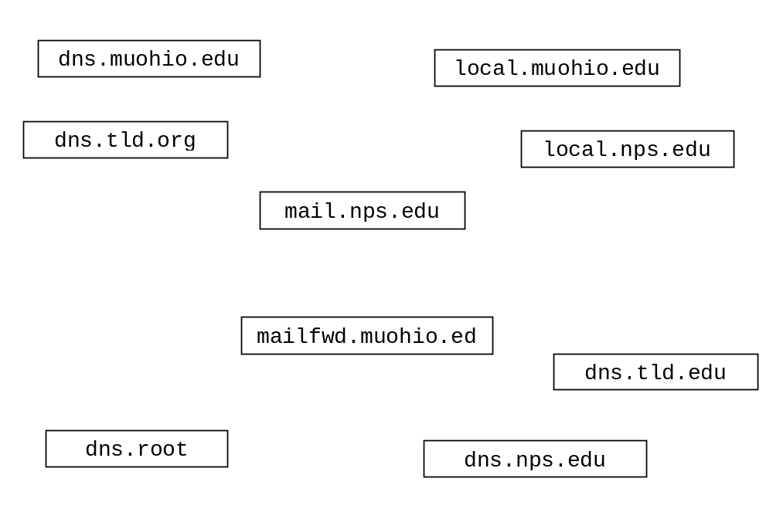
- What type of resource record would mail.nps.edu need to obtain initially? (circle one) (2 points)

Type A Type NS Type CNAME Type MX

- What type of resource record would actually contain the IP address of mailfwd.muohio.edu mail? (circle one) (2 points)

Type A Type NS Type CNAME Type MX

- After the sequence in part a. has occurred, suppose mail.nps.edu wants upload mail for fred@uc.edu. How would the sequence of events be different? (3 points)

13. In the previous two questions: (4 points)

  - What protocol would mail.nps.edu use to send the email message to mailfwd.muohio.edu?

  - Suppose the email message contained an image file attachment, what would have to be done to the attachment in order to send it along with the message? Why?

- Describe how the location of a file is found and from where it is downloaded in peer-to-peer file sharing system which uses a centralized index in a manner similar to Napster. (4 points)

- Complete the Server class below. Do not worry about handling exceptions. Allow the main method to throw all exceptions to the OS. (24 points)
(You may write your code on the back of a page.)
- Clients contact the Server and send one int followed by some number of floats using TCP. The absolute value of the int specifies how many floats will be sent. (java.lang.Math.abs() can be used to get the absolute value of a number.)
- The Server calculates the sum of the floats and sends the sum back to the client as a float.
- When the Server receives a negative int from a client, it will use the absolute value of it to calculate and return the sum of the floats to the client. The server itself will then close. (If the int is positive, the server will continue to run and service other clients.)
- The Server listens for clients on port number 9999.
- Do not use multi-threading. The server only needs to handle one client at a time. The Server handles clients sequentially.

import java.io.*;
import java.net.*;

public class SumServer {

public static void main(String[] args) throws Exception
{

} // end main
} // end SumServer class
- Complete the client class below. Do not worry about handling exceptions. Allow the main method to throw all exceptions to the OS. (24 points)
(You may write your code on the back of a page.)
- Write a client program that reads in a series of floats from the console. The user enters all of the floats on a single line and then presses enter. (You can use the nextFloat and hasNextFloat methods of the Scanner class to get the numbers out of the String.)
- The client program sends all of the numbers as floats to a server in a single packet using UDP.
- After sending the floats, the sum of the floats is received via UDP from the server as a single float and displayed to the console.
- Assume the user will enter a line containing valid numbers. The program should close after handling a single line of numbers.
- The server is at 131.1.22.6 and port number 9999.

import java.io.*;
import java.net.*;
public class SumClient {

public static void main(String[] args) throws Exception
{
BufferedReader br = new BufferedReader( new InputStreamReader( System.in ));
String numbers = br.readLine( );
Scanner ss = new Scanner( numbers );

} // end main
} // end ProductClient class
- In the preceding question, how will the server determine how many floats are being sent? Explain or write a short code fragment to illustrate how this will be done. (4 points)

